**Table of Contents**

1. Introduction
2. History of Computers
3. Components of a Computer
   * 3.1 Hardware
   * 3.2 Software
4. Types of Computers
5. Applications of Computers
6. Conclusion
7. References

**1. Introduction**

A **computer** is an electronic device that can process, store, and retrieve data. It helps people perform tasks faster and more efficiently. Computers have become a vital part of our daily lives, used in education, business, health, entertainment, and more.

**2. History of Computers**

The history of computers dates back to ancient times with tools like the **abacus**. The first mechanical computer was designed by **Charles Babbage** in the 1800s, known as the **Analytical Engine**. The modern computer era began in the 20th century with inventions like the **ENIAC**, one of the first electronic computers.

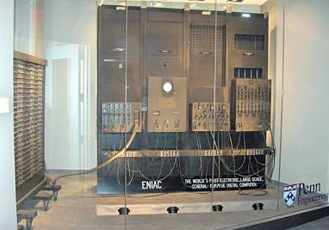

**3. Components of a Computer**

A computer is made up of two main parts: **hardware** and **software**.

**3.1 Hardware**

Hardware includes all the physical parts of a computer. Examples are:

* **CPU (Central Processing Unit):** The brain of the computer
* **Monitor:** Displays the output
* **Keyboard and Mouse:** Input devices
* **RAM and Hard Drive:** Memory and storage

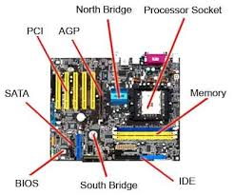  
  
**3.2 Software**

Software refers to the programs and instructions that run on a computer. There are two types:

* **System Software:** Like Windows or macOS, which manage the hardware
* **Application Software:** Like MS Word, web browsers, or games

**4. Types of Computers**

There are different types of computers based on size and usage:

* **Desktop Computers:** Used at homes and offices
* **Laptops:** Portable and compact
* **Tablets and Smartphones:** Small and handheld
* **Supercomputers:** Very powerful, used in research and weather forecasting

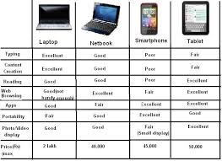

**5. Applications of Computers**

Computers are used in many areas:

* **Education:** Online classes, research, e-books
* **Business:** Emails, accounting, presentations
* **Health:** Patient records, medical equipment
* **Entertainment:** Games, movies, music
* **Science:** Data analysis, space research

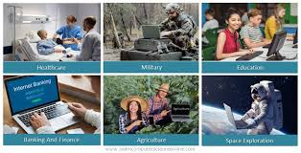

**Advantages and Disadvantages**

**Advantages:**

* **Fast and accurate**
* **Can store large amounts of data**
* **Help in communication (email, video call)**
* **Automate repetitive tasks**
* **Available 24/7 (machines don’t sleep)**

**Disadvantages:**

* **Can cause health problems (eye strain, poor posture)**
* **Dependence on computers can reduce thinking skills**
* **Data can be hacked if not protected**
* **Expensive to buy and maintain**

**7. Future of Computers**

**The future of computers is exciting and full of possibilities:**

* **Artificial Intelligence (AI): Computers that can think and learn**
* **Quantum Computing: Much faster and more powerful than current computers**
* **Cloud Computing: Data and software available online**
* **Smarter Devices: Homes, cars, and even cities using smart technology**

**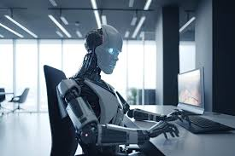  
  
  
  
  
6. Conclusion**

Computers have transformed the world. They make tasks easier and more efficient. Understanding how computers work and how they are used can help us make the most of technology in our daily lives.

**7. References**

1. Morley, D., & Parker, C. (2009). *Understanding Computers: Today and Tomorrow*. Cengage Learning.
2. Britannica. (2023). "Computer". Retrieved from <https://www.britannica.com/technology/computer>
3. History.com Editors. (2020). "Who Invented the Computer?" Retrieved from https://www.history.com/topics/inventions/computers
4. Computer Hope. (2024). "Computer Basics". Retrieved from https://www.computerhope.com/basics.htm